Name: Saurabh Sanjay Jadhav

Topic : Terraform variables and output.tf file.

Assignment no : 17

1. **Static Variables:**

/modules/ec2/main.tf

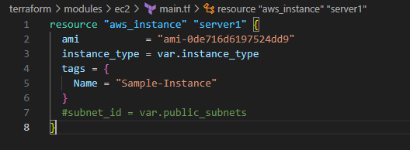

/modules/ec2/variable.tf

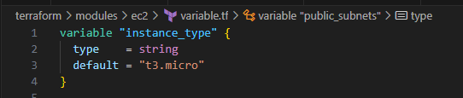

1. **On the go variable : The values of variable will given as input while running the code.**

/modules/ec2/main.tf



/modules/ec2/variable.tf



/terraform/main.tf

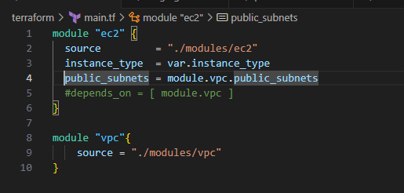

/terraform/variable.tf

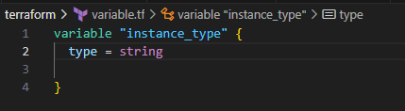

>> terraform plan

Enter value for instance type:

>> terraform destroy

Enter value of instance type for destroy :

1. **Create variables based on various environemnts.**

Create file staging.tfvars in /terraform directory

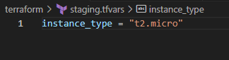

>> terraform apply –var-file=staging.tfvars

# It will provide EC2 instance type as t2.micro

>> terraform destroy –var-file=staging.tfvars

# It will destroy the resources based on variables details provided in staging.tfvars file

Similarly we can create production.tfvars in /terraform directory

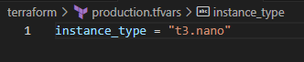

>> terraform apply –var-file=production.tfvars

# It will create Ec2 instance with instance type as t3.nano

>> terraform destroy –var-file=production.tfvars

# It will destroy the resources based on variables details provided in production.tfvars file.

🡺 To only destroy Ec2 instance and keep other resources as it is.

Terraform destroy –var-file=staging.tfvars –target=module.ec2

1. **Use of output.tf file: We can use this file to call variables or attributes of others modules.**

/terraform/modules/vpc/output.tf

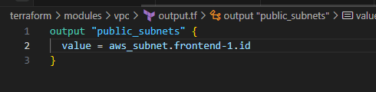

/terraform/main.tf

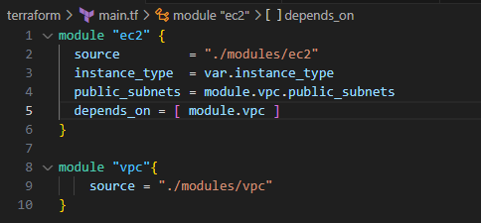

/terraform/modules/ec2/variable.tf

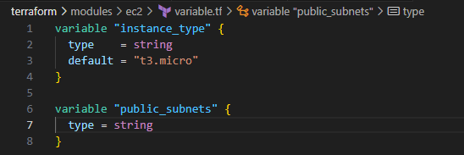

/terraform/modules/ec2/main.tf

